Assignment Tracker – Project Plan
Introduction
The Assignment Tracker is a web-based CRUD database with a simple design to assist students to manage their school assignments. The system enables the creation, viewing, editing, and deleting of assignment records, which gives the user a central location to handle due dates, progress, and course related tasks. It is aimed at minimizing missed deadlines and increasing productivity with a clean and easy to use interface.

Purpose of the Application
The Assignment Tracker is aimed at giving students a digital source of controlling upcoming assignments in various courses. The Assignment Tracker will enable users to put all that in structured online dashboard instead of having to use notes applications or paper lists.

Core Features
- Create new assignments with details.
- Read and display all assignments.
- Update assignment details and make changes regarding progress.
- Delete assignments with a deleted confirmation screen.
- UI designed using Bootstrap and custom CSS.
- Secure database connection using MongoDB Atlas with .env and .gitignore.
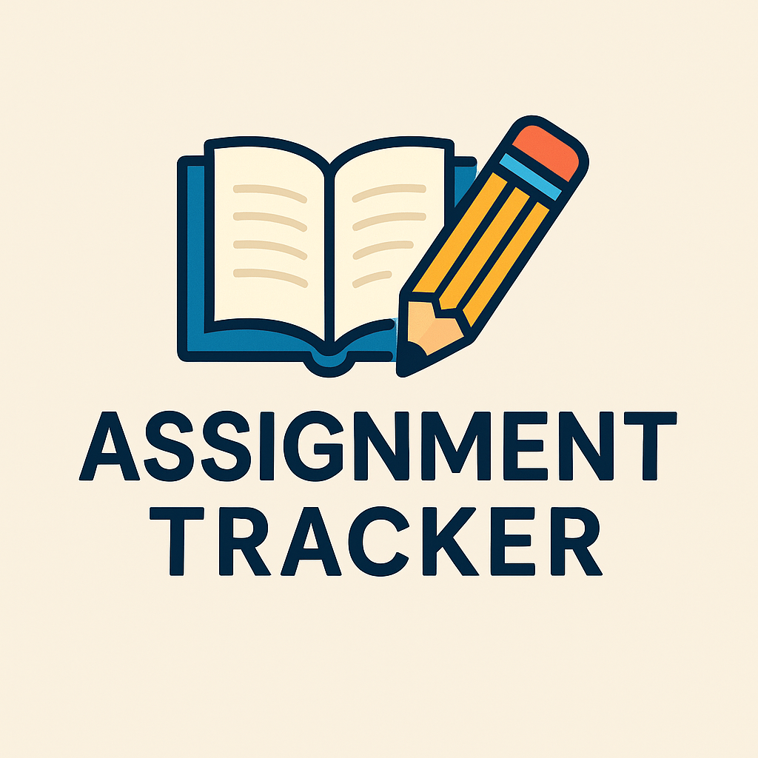 This is the logo, a simple logo not to confuse users and still remind them of the purpose for the website
Users
It is mainly intended to be used by college and university students who desire a straightforward device to keep track of coursework deadlines. The application is user-friendly on desktop browsers.

Visual Overview (Wireframe Description)
Home Splash Page
- Title, subtitle, and a button: “View Assignments”
- Light warm color theme for simplicity
Assignments List Page
- Navbar at top
- Logo
- Table showing:
  - Title
  - Course
  - Due Date
  - Status
  - Priority
  - Action buttons (Edit / Delete)
New Assignment Page
- Form with text input, date picker, dropdowns
- Save and Cancel buttons
Edit Assignment Page
- Same form pre-filled
- Update button

Delete Confirmation Page
- Warning message
- “Yes, Delete” + “Cancel” buttons

8. Why This App is Useful
A system offers students an opportunity to have deadlines visible, ease progress monitoring, and reduce academic stress. The software is user friendly and capable of handling numerous courses effectively.

